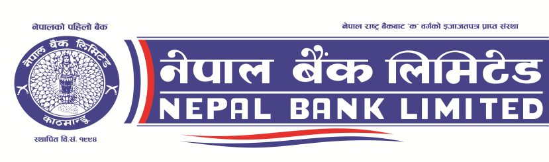

Head Office, General Service Department
Invitation for Electronic Bids (Second Notice)
Invitation for Bids No: NBL/NCB08/W080/81
Date of publication:2080/08/07
Nepal Bank Limited invites electronic bids from eligible bidders for Retrofitting & Renovation of Building No. 1, Head Office, Kathmandu under National Competitive Bidding.
Bids No. | Work Description | Last Date of Submission of Bid Document | Bid Opening Date, Time & Place | Tender Document Fee | Bid Deposit Amount | Bid Validity Period
NBL/NCB08/W080/81 | Retrofitting & Renovation of Building No. 1, Head Office | 2080-08-22  11:00 AM | 2080-08-22,  12:00PM  HO, GSD | 5000 | 9,00,000.00 | 120 days
Required criteria
Minimum Average Annual Construction Turnover: NRs 3,50,00,000.00
Minimum Bid Capacity: NRs 2,85,00,000.00
Information to deposit the tender document fee & bid deposit amount in Bank:
Name of the Bank : Nepal Bank Limited
Name of Office : Kathmandu Banking Office, Bhugolpark, Kathmandu
Account No.: 00200106711283000001 (Account Name: NBL Tender/Seal Quotation/Listing)
Account no.: 00200106711280000001 (Account Name.: NBL BID DEPOSIT ACCOUNT)

For detail information, visit PPMO website https://www.bolpatra.gov.np/egp/ & bank website: www.nepalbank.com.np.

Invitation for Bids
Nepal Bank Limited
Invitation for Bids No: NBL/NCB08/W080/81
Date of publication:2080-08-07

- Nepal Bank Limited has allocated funds for Retrofitting & Renovation of Building No. 1, Head Office, Kathmandu. Bidding is open to all eligible as per Section V of bidding document.
- Nepal Bank Limited invites electronic bids from eligible bidders for Retrofitting & Renovation of Building No. 1, Head Office, Kathmandu under National Competitive Bidding – Single Stage Two Envelope Bidding procedures.
Only eligible bidders with the following key qualifications should participate in this bidding:
- Minimum Average Annual Construction Turnover of the best 3 years within the last 10 years: NRs 35,000,000.00 (Rupees Thirty Five Million only)
- Minimum Work experience of similar size and nature: Participation as prime contractor, management contractor, or subcontractor, in at least ONE (1) contracts of Banks/Commercial/Institutional/Corporate/Government office buildings with retrofitting works within the last Ten (10) years, each with a value of at least NPR 12,700,000.00 (Rupees Twelve Million Seven Hundred Thousand only) with 13% VAT that have been successfully completed and that are similar to the proposed works.
- Under the Single Stage, Two Envelope Procedure, Bidders are required to submit simultaneously two separate sealed envelopes, one containing (i) the Technical Bid and the other (ii) the Price Bid, both in turn enclosed in one sealed envelope as per the provision of ITB 21 of the Bidding Document.
- Eligible Bidders may obtain further information and inspect the Bidding Documents at the office of Nepal Bank Limited, Head Office, General Services Department, Kathmandu, Nepal or may visit PPMO e-GP system www.bolpatra.gov.np/egp.
- Bidder may download the bidding documents for e-submission from PPMO’s e-GP system www.bolpatra.gov.np/egp. Bidders, submitting their bid electronically, should deposit the cost of bidding document (bid document fee Rs. 5000, non-refundable) in the bank’s bid deposit account as specified below .
Information to deposit Fee for Bidding Document in Bank:
Bank and Branch Name : Nepal Bank Limited, Kathmandu Banking Office
Account no. : 00200106711283000001
Account Name : NBL TENDER/ SEAL QUOTATION/LISTING
Information to deposit Bid Deposit Amount in Bank:
Name of the Bank : Nepal Bank Limited
Name of Office : Kathmandu Banking Office, Bhugolpark, Kathmandu
Office Account no.: 00200106711280000001
Account Name.: NBL BID DEPOSIT ACCOUNT
- Pre-bid meeting shall be held at Nepal Bank Limited, Head Office, General Services Department, Kathmandu at 2080-08-15 11:00 hrs.
- Electronic bids must be submitted to the office Nepal Bank Limited, Head Office, General Services Department, Kathmandu through PPMO’s e-GP system www.bolpatra.gov.np/egp on or before 11 hours on 2080-08-22. Bids received after this deadline will be rejected.
- The bids will be opened in the presence of Bidders' representatives who choose to attend at 12:00 hrs on 2080-08-22 at the office of Nepal Bank Limited, Head Office, General Services Department, Kathmandu. Bids must be valid for a period of 90 days after bid opening and must be accompanied by a bid security or scanned copy of the bid security in pdf format in case of e-bid amounting to a minimum of 9,00,000.00 (Nepalese Rupees Nine Lakh only), which shall be valid for 30 days beyond the validity period of the bid (total 120 days).
- If the last date of purchasing and /or submission falls on a government holiday, then the next working day shall be considered as the last date. In such case the validity period of the bid and bid security shall remain the same as specified for the original last date of bid submission.
- The bank reserves the right to accept or reject, wholly or partly any or all the e-bids without assigning any reason, whatsoever.

